Warning – Efficiency Achievement Level – PHEV_FHEV– CGEA 1.3

Functional Description

The purpose of the Efficiency Achievement Level Warning is to provide an HEV Eco Score HMI enhancement on the instrument cluster. The HEV System shall calculate and display a symbol of achievement depending on the level of the customers driving behavior over time and/or distance or other program approved measure. The display can be an image (like flowers), a number (like level 1,2,3,…), a combination of these items, or other program approved graphics.

The time, distance and/or other measure to attain the next Efficiency Achievement Level shall be calculated by the PCM.

During the drive, if the next level of efficient driving is earned, a message shall be displayed. The Efficiency Achievement Level graphics will be displayed with the efficiency leaves on the right hand display whenever the efficiency leaves are displayed. The vehicle shutdown screen shall include a sum of the total achievements earned over the life of the vehicle, unless the instrument cluster is replaced or customer reset selected. Reset of the Efficiency Achievement Level shall be tied to the Long Term Fuel Economy reset.

The Efficiency Achievement Level Warning correlates the DrvEffLvlIncDec_D_Cmd from the PCM and the Operational Mode to determine when to display the Efficiency Achievement Level message center warning.

Interfaces

Interface Context Diagram (I/O Block Diagram)

Figure 1 Warning – Efficiency Achievement Level
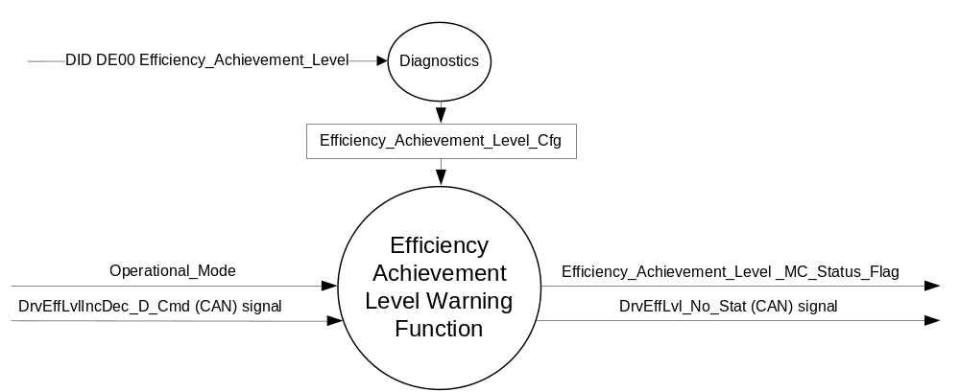

Inputs
      - INTERNAL:
    - Operational_Mode
    - Efficiency_Achievement_Level_Cfg
- MUX message from the CAN bus from PCM

- DrvEffLvlIncDec_D_Cmd Signal
Signal Name | Size (bits) | Detail | Units | Res. | Offset | State Encoded | Min | Max
DrvEffLvlIncDec_D_Cmd | 2 |  | SED | 1 | 0 |  | 0  (0x0) | 3  (0x3)
 |  | Null state |  |  |  | 0x0
 |  | Increase level by 1 |  |  |  | 0x1
 |  | Decrease level by 1 |  |  |  | 0x2
 |  | Not Used |  |  |  | 0x3

Output

      - INTERNAL:
- Efficiency_Achievement_Level _MC_Status_Flag that is used to control the Warning displayed in the message center.
- MUX message to PCM

- DrvEffLvl_No_Stat Signal
Signal Name | Size (bits) | Detail | Units | Res. | Offset | State Encoded | Min | Max
DrvEffLvl_No_Stat | 6 |  | SED | 1 | 0 |  | 0  (0x0) | 61  (0x3D)
 |  | Unknown |  |  |  | 0x3E
 |  | Invalid |  |  |  | 0x3F

Function/Performance

Operational Modes

Mode | Differentiating Vehicle Conditions
Sleep Mode | Efficiency_Achievement_Level _MC_Status_Flag = Inactive
Limited Mode | Efficiency_Achievement_Level _MC_Status_Flag = Inactive
Normal Mode | Efficiency_Achievement_Level _MC_Status_Flag = Inactive/Active
Crank Mode | Efficiency_Achievement_Level _MC_Status_Flag = Inactive/Active

The above table references the setting of the Warning flag as per this section. However, the actual warning display operational modes are displayed in the Message Center section of this SPSS.

Voltage Levels

Refer to the Cluster Features Table located in the Operational Modes and Voltage Range Strategies Section of this SPSS

Human-Machine Interface

Visual

1.3.3.1.1 Indicator Graphics / Display Format
Message Center Text Warning Message as defined in section 1.3.5.7 of this document.

1.3.3.1.2 Indicator Color Coordinates

Reference section COLOR & ILLUMINATION REQUIREMENTS (GRAPHICS).

Audio

None.

Switch Control Logic

None.

System Accuracy

Within 100 msec of receiving a message that results in a change of state the cluster will update the output flag to the proper state.

Operation: Performance and Functional

Subsystem Algorithm Flowchart / State Diagram

- State Matrix for Driver Efficiency Level Warning
Operational  Mode | Efficiency_Achievement_  Level_Cfg | Long Term  Fuel Economy | DrvEffLvlIncDec_D_Cmd | Driver_Efficiency_Level | Efficiency_Achievement_  Level _MC_Status_Flag
Normal | Enabled | X | 0x0 → 0x1 | Driver_Efficiency_ Level + 1 | ACTIVE
Normal | Enabled | 0 | X | 0 | INACTIVE
Normal | Disabled | X | X | 0 | INACTIVE
All Other Cases |  |  |  | Driver_Efficiency_ Level | INACTIVE

Operation Description (supports algorithm flowchart /state diagram)

- When Efficiency_Achievement_Level _MC_Status_Flag = ACTIVE, Warning ID W1002 will be ACTIVE.
- For definition of how the Message Center arbitrates and displays Active warnings, see the Warning / Alert Display Logic Diagram, located in the Message Center – X Display with W Button Interface section of this SPSS (where X and W are appropriate values in this document).
- DrvEffLvl_No_Stat shall be set equal to Driver_Efficiency_Level.
- Driver_Efficiency_Level shall increment when DrvEffLvlIncDec_D_Cmd transitions from 0x0 to 0x1 and the feature is Enabled and shall be stored in cluster non-volatile memory (EEPROM)
- Driver_Efficiency_Level shall be set to 0 whenever Long Term Fuel Economy is Reset to 0.
- The Efficiency Achievement Level graphics will be displayed with the efficiency leaves on the right hand display whenever the efficiency leaves are displayed, including the vehicle shutdown screen.

Example of CD3 Lincoln HEV MY11 implementation:

5 Flowers with 3 growth stages for each flower = 15 ECO LEVELS (contained in the graphics Keep In Area)
Level 1 - Flower A (Small)
Level 2 - Flower A (Med)
Level 3 - Flower A (Large)
Level 4 - Flower B (Small)
Level 5 - Flower B (Med)

A, B, C etc are the locations of each flower

Warning Pop up on the left side to alert to appear at each level and will use a MED flower display

Example of CD4.1 Lincoln HEV MY13 implementation:
9 Flowers with 3 growth stages for each flower = 27 ECO LEVELS

Long Term Acheivement  (DvrEffLvl_No_Stat) | Positional Reference | Long Term Emotive Increment  (Flowers in Lincoln MKZ HEV)
0 | No Flowers | No Flowers
1 | Flower 01a | Flower 1 Small
2 | Flower 01b | Flower 1 Medium
3 | Flower 01c | Flower 1 Large
4 | Flower 02a | Add Flower 2 Small
5 | Flower 02b | Flower 2 Medium
6 | Flower 02c | Flower 2 Large
7 | Flower 03a | Add Flower 3 Small
8 | Flower 03b | Flower 3 Medium
9 | Flower 03c | Flower 3 Large
10 | Flower 04a | Add Flower 4 Small
11 | Flower 04b | Flower 4 Medium
12 | Flower 04c | Flower 4 Large
13 | Flower 05a | Add Flower 5 Small
14 | Flower 05b | Flower 5 Medium
15 | Flower 05c | Flower 5 Large
16 | Flower 06a | Add Flower 6 Small
17 | Flower 06b | Flower 6 Medium
18 | Flower 06c | Flower 6 Large
19 | Flower 07a | Add Flower 7 Small
20 | Flower 07b | Flower 7 Medium
21 | Flower 07c | Flower 7 Large
22 | Flower 08a | Add Flower 8 Small
23 | Flower 08b | Flower 8 Medium
24 | Flower 08c | Flower 8 Large
25 | Flower 09a | Add Flower 9 Small
26 | Flower 09b | Flower 9 Medium
27 | Flower 09c | Flower 9 Large
28-63 | All flowers remain on in large state | All flowers remain on in large state

Note: Once a flower is on, it stays on until reset. So when
you get to flower 2, 1 stays on as large, when you get to
flower 3, 1 and 2 remain on as well in their large state, etc.

Function Safety Classification (EMC)

Class B

Memory Storage

Parameter Name | Description | Value at  Battery Connect | Value at  Module Wake-up
Operational_Mode | 4 state indicator for cluster operational mode | Limited | Limited or Normal or Crank
Efficiency_Achievement_Level_Cfg | Configuration bit used to Enable/Disable the Efficiency Achievement Level Feature | Use Stored Value | Use Stored Value
DrvEffLvlIncDec_D_Cmd (CAN) | Signal sent from PCM. | Null state (0x0) | Null state (0x0)
DrvEffLvl_No_Stat (CAN) | Signal sent by IPC. | Use Stored Value of Driver_Efficiency_Level | Use Stored Value of Driver_Efficiency_Level
Efficiency_Achievement_Level _MC_Status_Flag | State Variable used by M/C Warning Arbitrator | Inactive (0x0) | Inactive (0x0)
Driver_Efficiency_Level | State Variable used to track Efficiency Achievement Level | Use Stored Value | Use Stored Value
Long Term Fuel Economy | State Variable used to track Long Term Fuel Economy – Parameter stored in EEPROM | Use Stored Value | Use Stored Value

Prove Out

No.

Reconfigurable Telltale

No.

Message Center Msg

Warning Message ID W1002 as defined in the Text Message List section of this SPSS.

Error Handling

Missing Message Strategy

The signals will be declared Invalid as per the Diagnostics Section of this SPSS.
DTC states and history will be determined as per the Diagnostics Section of this SPSS.

Diagnostics

Self Test

None

Engineering Test Mode

Not Applicable

Part II Performance

Supported Diagnostic Trouble Codes (DTCs)

DTC | Description | When Logged
C10000 | Lost Communication With PCM | HS_CAN message missing for more than 5 seconds

DID DE00 Configuration
Block  Num | Block Description | Byte(s) | Bits | State: Description | "0" | "1" | Default | Comments/ Information
PACKETED BLOCKS
$00 | Option Content (B&A) | * | * | Efficiency_Achievement_Level | Disabled | Enabled | Disabled | Enabled on Lincoln HEV’s to allow display of flowers.
*Byte and bit location to be identified in Part II Specification for this cluster

Reference Specification

Revision History

SPSS Module Revision History

Revision  Level | Name | Change Description | Date
1.0 | S. Watkins | Modified from FNA version 1.0 from 2011 Lincoln CD3 HEV. Besides minor formatting, only real change is that CD3 HEV had 15 levels of flowers, and now 2013 CD4.1 HEV has 27 levels of flowers. | 1/12/2012

